Edexcel A-Level – Business Studies
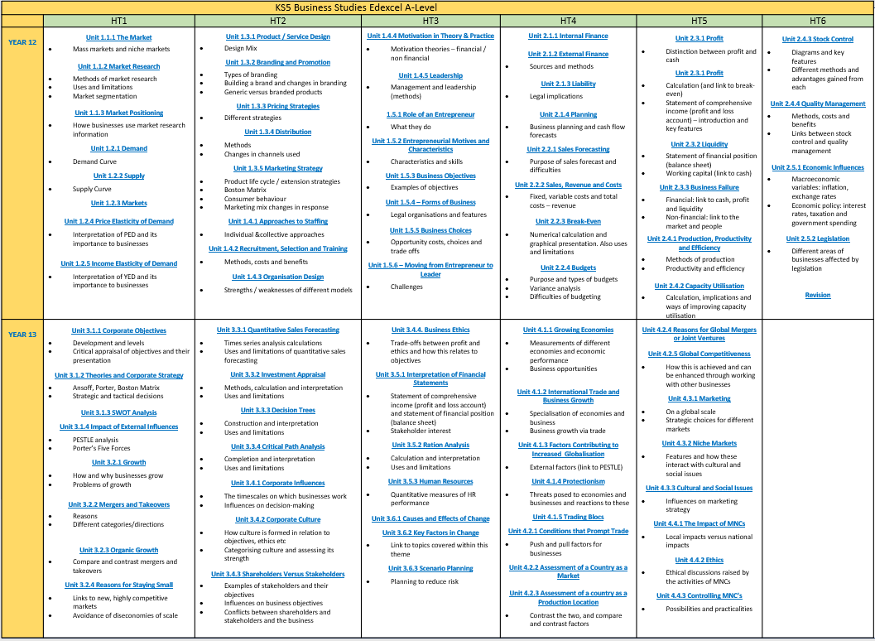

BTEC Level 3 National Business – Pearson



