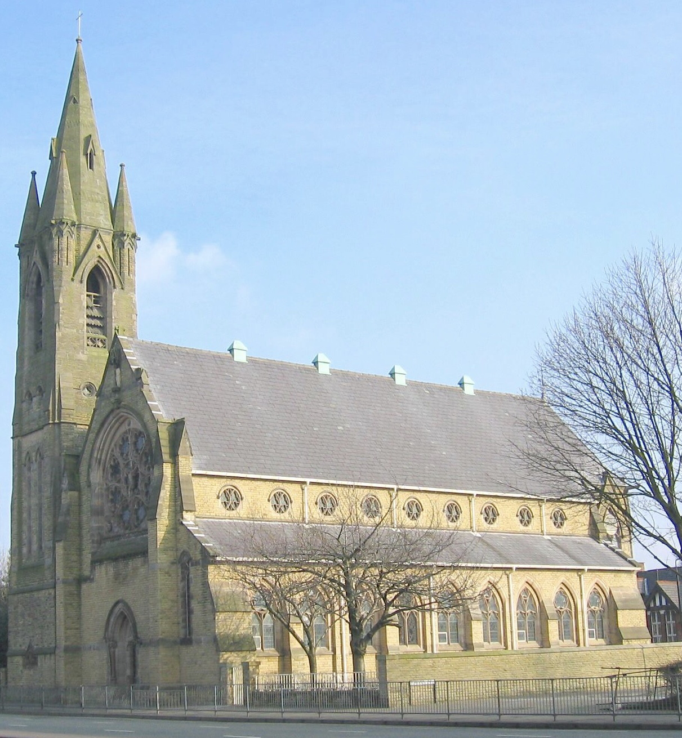
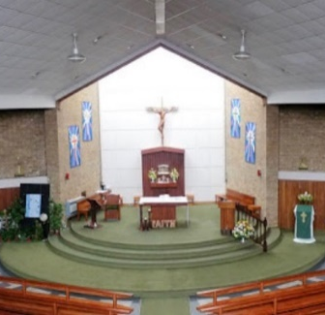
January 2026

St Ann’s Presbytery
1043 Chester Road
Stretford
Manchester
M32 8LF
0161 865 2079

Gerald.Murphy@dioceseofsalford.org.uk

Confirmation Programme
Dear Parent,
Your son / daughter is eligible to enrol for the Parish Confirmation Programme (pupils in Year 8 or above). In advance, thank you to St Antony’s High School for hosting the sessions and to our Catechists for giving up their time.

The initial enrolment will take place on Thursday 5th February at 6pm in the Church of St Ann’s in Stretford. During the enrolment, we shall celebrate Mass and share further details of the Programme. Please note the following key dates:
- Thursday 5th February 6pm – Mass and enrolment (St Ann’s Church, children and parents)
- Thursday 12th March 5pm (until 6pm)– Session 1 (St Antony’s, children only)
- Thursday 23rd April 5pm (until 6pm) – Session 2 (St Antony’s, children only)
- Thursday 14th May 5pm (until 6pm) – Session 3 (St Antony’s, children only)
- Sunday 28th June 2pm – The Confirmation Service (St Monica’s church, Flixton))

In addition to the above, and in advance of the enrolment, please complete the form overleaf. Forms can be returned via myself or directly to Paul Giblin (p.giblin@st-antonys.com). For those not baptised in either St Hugh of Lincoln or St Ann’s, a photograph of the original baptismal certificate can be sent to the above email.

We look forward to hearing from you

Yours in Christ
Fr Ged Murphy PP

Confirmation Registration Form

Name of candidate…………………………………….
Address of candidate………………………………….………………………………….…………………
…………….………………………………….………………………………….………………………………..
Contact phone number (for emergency)…………………………………………………………….
Next of kin name………………………………………
Candidate’s date of birth……………………………
Candidate’s date of baptism…………………………… (please provide certificate if not at St Ann’s or St Hugh of Lincoln)
I give / I do not give permission to use my child’s photo in church / Facebook or Twitter (please circle)

Signed…………………………………

I consent to my child being Confirmed, I will bring them to the Sessions and to Mass as often as possible. Signed…………………………………… Date………………………………….

Please bring this completed form to the Enrolment Mass.

