How to access work for pupils isolating/shielding – March 2021 onwards
- Sign into Microsoft Teams
You will see your classes displayed
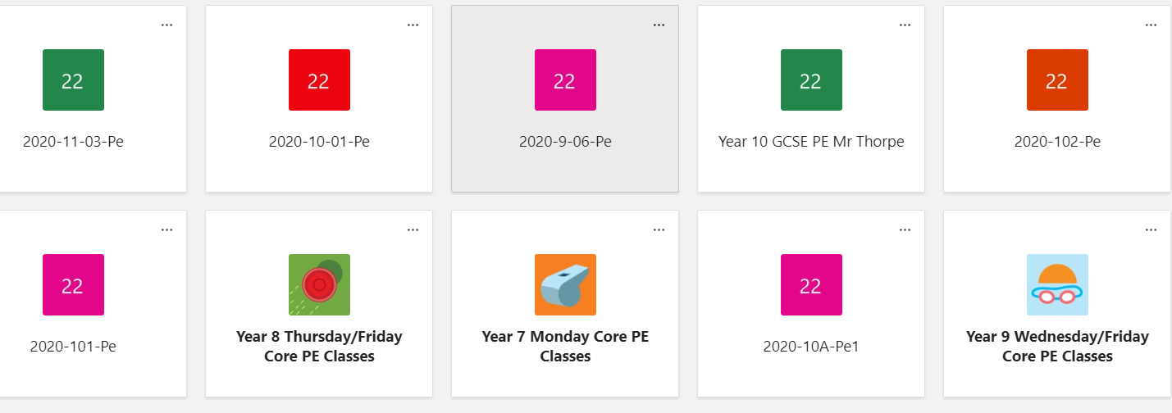

- Following your normal timetable for the day you are having to isolate for. Select the lesson you would be in. If you have any difficulties finding the work set, please email your class teacher directly.

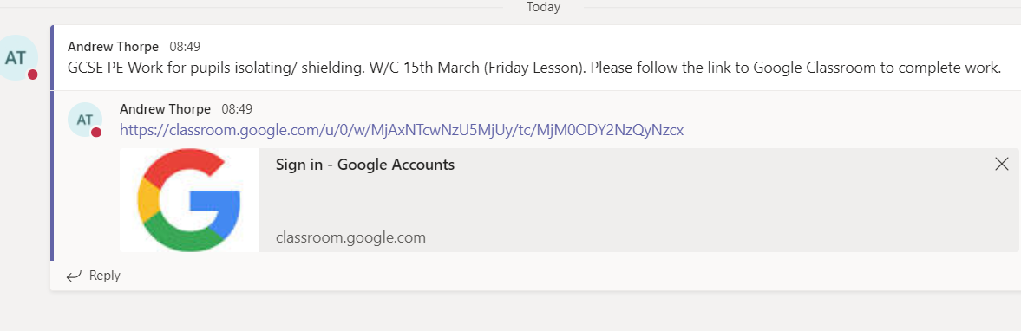
- Once you have selected the appropriate lesson, your instructions will be on the main page. They will be clearly labelled with the week commencing and instructions of what you need to complete. You may be required to click on a link that will take you to Google Classroom/ Google Drive/ Website – please read the instructions carefully.

